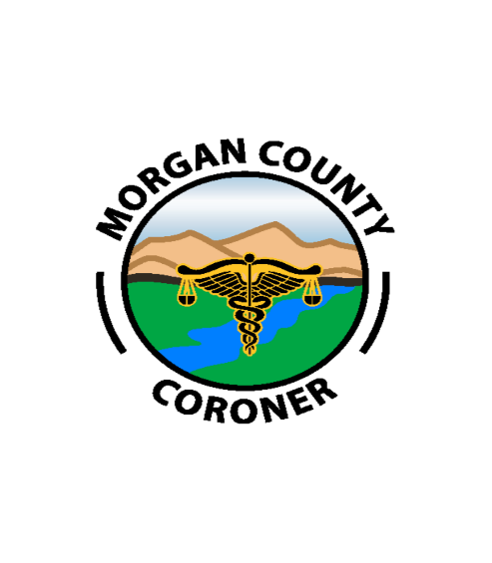
Morgan County Coroner’s Office

212 S. West Street Fort Morgan, CO 80701

Telephone: (970) 842-4955
Telefax: (970) 867-7344

Deputy Coroner Training Policy and Process

Both basic and in-service training for deputy coroners is critical to the successful completion of the mission of the Morgan County Coroner’s Office. Therefore, it is the policy of the Coroner’s Office to provide relevant and consistent training to all deputy coroners throughout the year.

The training of Morgan County deputy coroners consists of three tiers:

Orientation Training
Each newly-employed deputy coroner must complete a comprehensive checklist of more than 270 items that range from an understanding of office policies to the technical performance of coroner- related duties in the field, in the morgue and at autopsy. The checklist is completed over a period of months by the Coroner and the individual employee; the employee is immediately oriented to policies and procedures that are common to most or all cases; some specific types of death, such as a hypothermia case or deaths related to an aircraft crash, may not be “checked off” for a protracted period of time.

A copy of the current orientation checklist is attached to this document.

Basic Training
The Morgan County Coroner’s Office has adopted the recognized training and certification process overseen by Colorado Coroner’s Association. We encourage Deputies to achieve American Board of Medicolegal Death Investigator status, a process that takes many months.

In-Service Training
All personnel, regardless of currently-held certifications, are required to attend and participate in communal every year.

Communal training is performed with the entire staff about four to five times annually. The subject matter may range from mass casualty planning updates to information from organ and

tissue donation agencies. These sessions do not provide continuing education credits for the staff.

The identification of training needs is the responsibility of both the management team and the individual deputy coroner. In early 2023, each deputy coroner will complete a personal training needs assessment. The management team will review the needs assessment for each deputy coroner and attempt to match available coursework to the personal needs assessment and the management team’s perception of what in-service training would be most helpful to the staff member.
Once training needs are identified, they may be met by attendance at conferences or meetings that offer approved continuing education hours, or by participation in computer-based learning from such organizations as the University of North Dakota or the Death Investigation Training Academy.
A copy of the self-assessment instrument is attached to this document.

Morgan County Coroner’s Office Basic Training Checklist

LEARNER: DEMONSTRATED PERFORMED PRECEPTOR
Administrative
INTRODUCTION TO Morgan COUNTY GOVERNMENT
INTRODUCTION TO COLORADO CORONER LAW AND PRACTICE
BUILDING ACCESS (KEYS AND CODES)
FAMILIARIZATION WITH BUILDING AND OFFICE
EMERGENCY PROCEDURES AND EVACUATION PLAN
BUILDING AND OFFICE SECURITY
COUNTY CODE / BULLETIN BOARD
OATH OF OFFICE
POLICY AND PROCEDURES
DESK ASSIGNMENT
DESK TELEPHONE ASSIGNMENT
CELL PHONE
COMPUTER ACCESS TO SERVERS
E-MAIL CONTACTS
MDI LOG ACCESS
RESEARCH FAMILY MEMBERS
TIMESHEET ACCESS AND UNDERSTANDING
TIME OFF REQUESTS
BUSINESS CARDS
OPEN DOOR POLICY
IMMUNIZATIONS
GAS CARD
OVERTIME/COMP TIME
LOST, STOLEN, DAMAGED EQUIPMENT
MILEAGE REIMBURSEMENT
RELEASE OF INFORMATION
SUPPLY INVENTORY
MAINTENANCE REQUESTS
EMPLOYEE DRESS CODE REQUIREMENTS
GRATUITIES POLICY
SCHEDULING AND WORK HOURS POLICIES
WORKERS’ COMPENSATION POLICIES AND REPORTING INJURY
SOCIAL MEDIA AND INTERNET POLICIES
ON-CALL POLICIES

Orientation
FAMILIARIZATION WITH MORGUE
PERMITTING ACCESS TO DECEDENTS
FAMILIARIZATION WITH AUTOPSY CENTERS
PARKING PRIVATE AND COUNTY VEHICLES

HOSPITAL ACCESS AND ORIENTATION
HR/FUEL PUMPS/FLEET/CLINIC/WASH BAY
MCSO/ LEADPD/EVIDENCE
JAIL
RECORDS AND DISPATCH
HEALTH DEPARTMENT
JURISDICTIONAL LINES

Facility Equipment
FILING CABINETS
IN BOX
MEDICAL RECORD STORAGE
STORAGE AREAS
COPIER/SCANNER
BODY COOLER
WALK-IN COOLER (BLOOD, OTHER SPECIMENS)
DNA STORAGE
MEDICATION ROOM
PROPERTY LOCKER
MORGUE OFFICE
FILE ROOM, LOCKERS, BATHROOM, SHOWER
LAUNDRY WASHER AND DRYER (OPERARION)
BIOHAZARDOUS WASTE (TRASH, SHARPS, DRUGS)
PILL COUNTING / STORAGE
LIFT (ORIENTATION)
PAPER FINGERPRINTS
DIGITAL FINGERPTINT SCANNER
HISTOLOGY

Personal Equipment
WAR BAG
RADIO
GLOVES - WHEN TO USE WHICH KINDS
EYE PROTECTION
TYVEX SUIT
FACE MASKS (N95, RESPIRATOR)
BOOTIES AND SLEEVES
FOOTWEAR POLICIES

Vehicle Use & Equipment
RADIO
EMERGENCY LIGHTING AND SIREN
NAVIGATION (MAPS)
CAMERA BOX
LIFT LOADING SYSTEM (USE, SAFETY & MAINTENANCE

MANUAL COTS (USE, SAFETY & MAINTENANCE)
BACK BOARD (USE, SAFETY & MAINTENANCE)
SLIDER BOARDS (USE, SAFETY &MAINTENANCE)
SLINGS/STRAPS
BODY BAGS (LIGHT & HEAVY)
BODY BAG EVIDENCE SEAL
PROPERTY/EVIDENCE BAGS
REENACTMENT DOLL
FLASHLIGHT, FIRE EXTINGUISHER
VEHICLE MAINTENANCE (FUEL, WASH, FLUIDS, DAMAGE, MILES)
VEHICLE POLICIES (SEAT BELT, PASSENGERS, SMOKING, TAKING VEHICLE OUT OF WELD COUNTY)
INVENTORY SUPPLY
AED

Computer Systems
G-DRIVE – (FORMS, LETTERHEAD, SCHEDULES, HOSPICE, ETC...)
MORGUE CENSUS
MDI-LOG – CREATING A CASE FILE
MDI LOG – LAW SCREEN
MDI LOG – STATUS/FOLLOW UP
MDI LOG - INVOLVEMENTS
MDI LOG - NARRATIVES
MDI LOG - SUPPLEMENTS
MDI LOG – CASE MANAGEMENT
MDI LOG – SUBMITTING REPORTS
MDI LOG - CAD
EDR – GENERAL
EDR- PENDING VS. AMENDED
EDR – TRANSFER OF JURIDICTION
EDR – CO-SIGN/DROP TO PAPER/CREATING NEW
FAMILY MEMBERS FAMILYTREENOW
CASE FILE MANAGEMENT
GOOGLE (EMAIL, CALENDARS)
FAX LINE

Death Reporting
NOTIFICATION FROM DISPATCH
1ST CALL SHEETS
HOSPICE/NURSING HOME REPORTABLES
HOSPICE/NURSING HOME LINE
REPORTS (LONG VS. SHORT FORMATS)
TRANSFER OF JURISDICTION
NON-DISPATCH NOTIFICATIONS (HOSPITAL, OUTSIDE CORONER’S OFFICES, FUNERAL HOMES)

MEDICAL RECORD REQUEST COHIRO PC 360
SUIDI FORMS
OTHER SCENE SPECIFIC FORMS

Body Intake
MORGUE CENSUS
BOOK
IDENTIFICATION TAG
MORGUE LOG
WHITE BOARD
LIFT (OPERATION)
ADDITIONAL PHOTOGRAPHS
PERSONAL EFFECTS (CLEANING, SECURITY, INVENTORY)
FINGERPRINTING
BIOHAZARDOUS STICKERS, PACKAGING
EXTERNAL EXAMS
TOXICOLOGY (SAFETY, TECHNIQUES, STORING)
MEDICATION INVENTORY

Body Release
FAMILY RELEASE
RELINQUISHMENT OF RIGHTS (BODY & PROPERTY)
ROLE OF THE PUBLIC ADMINISTRATOR
BODY IDENTIFICATION (RELATIVES VIEWING THE BODY)
DECEDENT CLOTHING
HOLDS
WHITE BOARD
MORGUE LOG
PROPERTY RELEASE (LOG AND PAPERWORK)
MORGUE CENSUS
MDI LOG UPDATE

Notifications
COMMAND STAFF
DETERMINING THE NEXT OF KIN
NEXT OF KIN (IN PERSON, OVER THE PHONE)
ORGAN AND TISSUE DONATION AGENCIES
CONSULATE
DISTRICT ATTORNEY
LAW ENFORCEMENT JURISDICTION
HEALTH DEPARTMENT

Scene Investigation
JURISDICTION CONFIRMATION
RESPONSE TIME/NOTIFICATION TO DISPATCH
INITIAL CONTACT (LE/FIRE/NOK)

SCENE/ENVIORNMENTAL ASSESSMENT & SAFETY
ROLE OF THE VICTIM ADVOCATE
4TH AMENDMENT (WARRANTS, ESTABLISHING OWNERSHIP, SEARCHES)
PROPER PPE
LE INTERVIEW
NOK INTERVIEW
REENACTMENT POLICY FOR CHILD DEATHS
MANDATORY REPORTS OF ELDER ABUSE OR NEGLECT AND CHILD ABUSE
FIRE/EMS INTERVIEW
BODY IDENTIFICATION
SCENE PHOTOGRAPHY
BODY PHOTOGRAPHY
BODY EXAMINATION
ESTABLISHING TIME OF DEATH
PERSONAL EFFECTS (ON OR NEAR THE BODY)
COLLECTION OF EVIDENCE (SUICIDE NOTES, DRUGS, WEAPONS)
BAGGING OF HANDS
PACKAGING THE BODY FOR TRANSPORT (BODY BAGS, ID TAGS, SEALING THE BAG)
REMOVING BODY FROM SCENE
RELEASING PROPERTY FROM THE SCENE
RELEASING THE BODY FROM THE SCENE
PRIMARY CONTACT PERSON FROM SCENE
FOLLOW-UP INVESTIGATION (ANTEMORTEM FINGERPRINTS, PCP INTERVIEW, NOK INTERVIEW, RECORDS)
CASE UPDATE TO SUPERVISOR

Autopsy
AUTOPSY PREP SHEETS
AUTOPSY FOLDERS
AUTOPSY LABELS
NOTIFICATION TO PD FOR AUTOPSY TIME AND PLACE
BODY PREP (CLOTHING, JEWELRY)
ARRIVAL FOR SCHEDULED AUTOPSY
AUTOPSY CONDUCT (FOOD, DRINK, CLEAN AREAS, FP/DIENER/LE INTERACTION)
AUTOPSY PPE
AUTOPSY POLICY (BOOK, STICKERS, WORKSHEET)
PAPERWORK AT AUTOPSY
PHOTOGRAPHY
EVIDENCE COLLECTION (HOMICIDE KIT, SWAB DRYER, GSR KITS, PAPER BAGS, TOX BOXES, ETC…)
CLOTHING AND PROPERTY
BODY PACKAGING (BAGS AND PLASTIC)
COLLECTING ADMISSION SAMPLES / NO AUTOPSY

DC WORKSHEETS
FINGERPRINTS AND ID CARD
DNA CARDS
RELEASING EVIDENCE TO LE
PROPERTY/BODY LEAVING AT AUTOPSY
HOSPITAL/PRIVATE/COUNTY AUTOPSIES

Case Management
FIRST THINGS FIRST (CENSUS, BOOK, MDI LOG,)
STATUS/FOLLOW-UP
NATURAL DEATHS
AUTOPSY CASES
NON-NATURAL, NON-AUTOPSIED CASES (LABELS)
DEATH CERTIFICATES (PENDING, FINAL)
SUBMITTING FOR SUPERVISOR REVIEW
HOLD FOR MONITORING
RECEIVING AUTOPSY REPORTS
AMENDING DEATH CERTIFICATES
SCANNING
COMMUNICATION WITH FAMILY
REPORT DEADLINES
LONG REPORTS VS. SHORT REPORTS
SUPPLEMENTS
PARTITIONS
UPLOADING PHOTOS AND MEDICAL RECORDS MDI LOG
UPLOADING REPORTS TO MDI LOG

Death Investigations
IDENTIFICATION
NOK NOTIFICATION
DONOR ALLIANCE/RMLEB
LESS THAN 24-HOUR HOSPITAL DEATHS
OVER 24-HOUR HOSPITAL DEATHS (DELAYED DEATHS)
HOSPITAL ADMISSION SPECIMENS
MEDICAL RECORD REQUEST (HOSPITAL/PCP)
FETAL DEMISE
TRANSFER OF JURISDICTION OUT
TRANSFER OF JURISDICTION IN
INCIDENTS THAT BEGIN OUTSIDE OF COLORADO
HOSPICE
NURSING HOME
ASSISTED LIVING
FALLS
DECOMPOSITION
NATURAL SCENE
ACCIDENT (GENERAL)

SUICIDES (GENERAL)
HOMICIDE (GENERAL)
CHILD/INFANT DEATH
MOTOR VEHICLE ACCIDENTS
FIREARM DEATH
IN-CUSTODY DEATHS
OFFICER INVOLVED SHOOTING
CARBON MONOXIDE DEATHS
DRUG DEATHS
ETOH (CHRONIC VS. ACUTE)
DROWNING
HANGINGS
FIRE DEATHS
MULTIPLE FATALITIES
AIRCRAFT CRASHES
BLUNT FORCE INJURY
SHARP FORCE INJURY
THERAPEUTIC COMPLICATIONS AND MEDICAL MISADVENTURES
EXPOSURE-RELATED DEATHS (HYPO VS. HYPER)
ASPHYXIATION (CHEMICAL, POSITIONAL, MECHANICAL)
ELECTROCUTION DEATHS
HUMAN VS. NON-HUMAN REMAINS

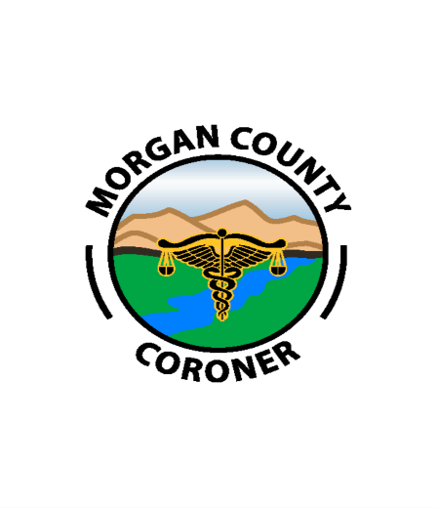
Morgan County Coroner’s Office

212 S. West Street Fort Morgan, CO 80701

Telephone: (970) 842-4955
Telefax: (970) 867-7344

Training Assessment for Coroner Personnel

Please list 3 to 5 areas of coroner responsibilities in which you believe that additional training could improve your performance. Training suggestions may be as specific as “blood spatter recognition,” “report writing” and “scene photography,” or as general as “pathophysiology of common causes of death.” Please list these areas in the order of perceived importance to your work performance.

1.
2.
3.
4.
5.

Please list 3 areas of coroner responsibilities in which you believe that your knowledge base is sufficient to offer training to the staff. The training does not have to be a formal or fancy presentation, but can simply be a discussion of something that you know that can help the rest of us.

1.
2.
3.

Staff Member: Date:

